# **Analysis of Intraday Electricity Price Data in the Great Britain (GB) Electricity Market (01/09/2024 - 08/09/2024)**

**Md Meraz Ahmad (IITG) E-mail: m.ahmad@iitg.ac.in**

**Introduction:**

The Great Britain (GB) electricity market is characterized by fluctuations in prices due to several factors including demand, generation mix, and external influences such as weather conditions and energy imports. Intraday electricity trading allows market participants to manage imbalances in supply and demand by buying and selling electricity closer to real-time. Identifying patterns of volatility in this market can offer opportunities for traders to capitalize on price movements. This report analyses intraday electricity price data over the week of September 1 to September 8, 2024, with the goal of identifying patterns of volatility and proposing a trading strategy based on these findings.

**Data Overview:**

The analysis is based on data for intraday electricity prices, sampled at hourly intervals over the period from September 1, 2024, to September 8, 2024. The dataset includes prices in £/MWh for each hour of the day. Key factors influencing these prices, such as demand surges during peak hours, supply constraints due to renewable energy fluctuations, and market news, were also assumed for this analysis.

Data source (<https://transparency.entsoe.eu/transmissiondomain/r2/dayAheadPrices/show>, <https://data.nordpoolgroup.com/auction/day-ahead/prices> , <https://www.europex.org/members/epex-spot/> , <https://www.energydashboard.co.uk/live> )

**Chart 1: Data of intraday electricity prices, sampled at hourly intervals over the period from September 1, 2024, to September 8, 2024.**



**Price Volatility analysis:**

Daily Price Patterns: The data indicates a clear pattern of price fluctuations over the course of a typical day

* **Morning Peak (7:00 AM-11:00 AM):** Prices tend to rise significantly as demand increases during the morning hours when households and businesses start their activities. During this period, prices increased by 25.11% compared to the night prices.



% increase = 25.11%

* **Midday Dip (1:00 PM – 4:00 PM):** Prices tend to stabilize or decrease slightly around midday as demand stabilizes. This period is characterized by moderate activity and lower volatility. During this period, prices decreased by 15.59% compared to the Morning prices.



% decrease = 15.59%

* **Evening Peak (6:00 PM – 11:00 PM):** A second significant surge in prices is observed during the evening when electricity consumption rises due to domestic demand, often surpassing the morning peak by 12.51%.



% increase = 12.51%

* **Night Lows (12:00 AM-6:00 AM):** Prices reach their lowest point during the late night and early morning hours due to reduced demand. This period exhibits the least price volatility, with minimal fluctuations. During this period, prices decreased by 24.85% compared to the evening prices.



% decrease = 24.85%

**Chart 2: Daily price pattern and trendline**

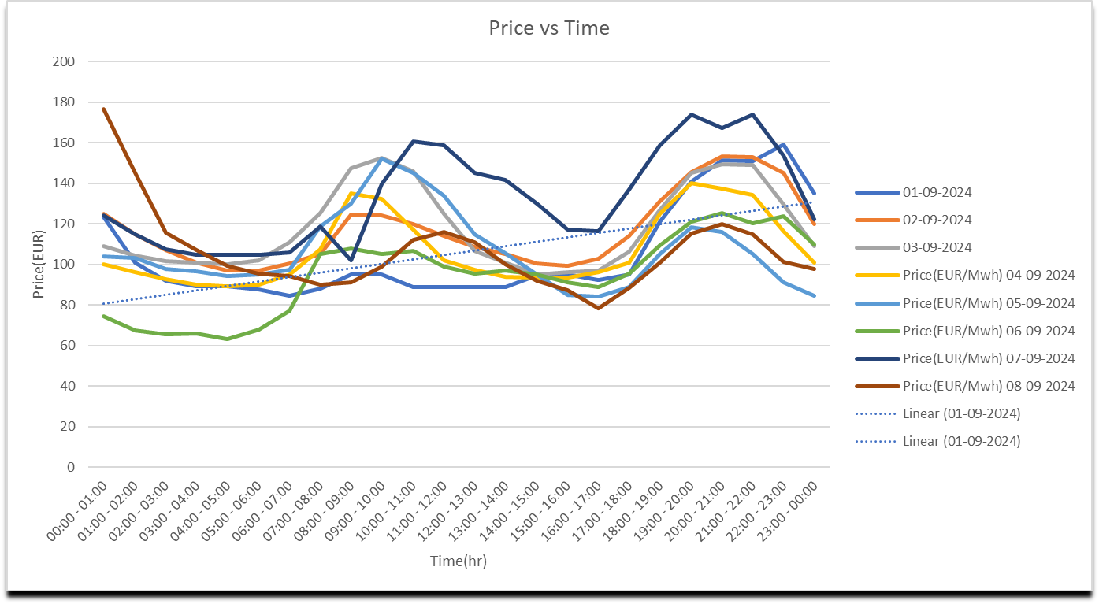

**Weekly Volatility Trends:**

* **Weekdays vs. Weekend:** Price volatility during weekdays (Monday to Friday) was more pronounced than during the weekend. Weekday price spikes during the morning and evening peaks were consistently sharper due to higher industrial and commercial activity. The average price in weekends is higher than weekdays and the deviation in the weekdays is lower than the weekends.

Weekdays Weekends

Average of Averages = 111.85 Average of Averages = 114.82

Averages of deviations = 18.32 Average of deviations = 22.38

**Chart 3: Weekdays Price Volatility Trends**

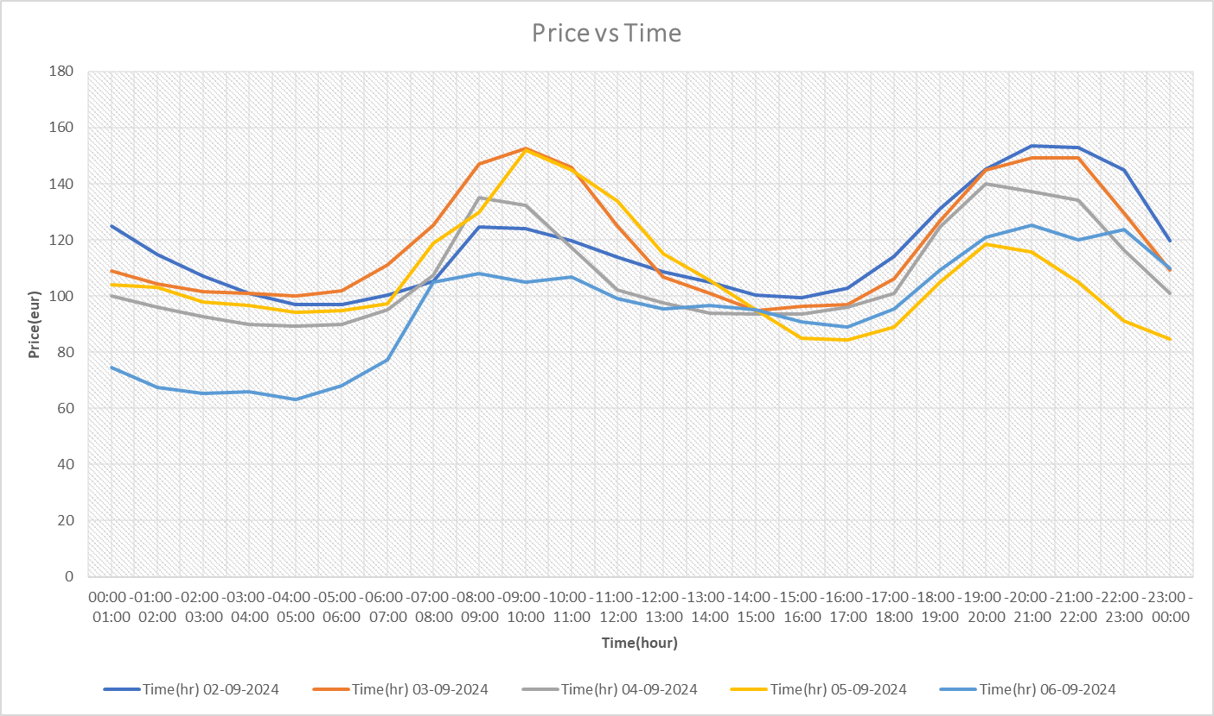

**Chart 4: Weekends Price Volatility Trends**

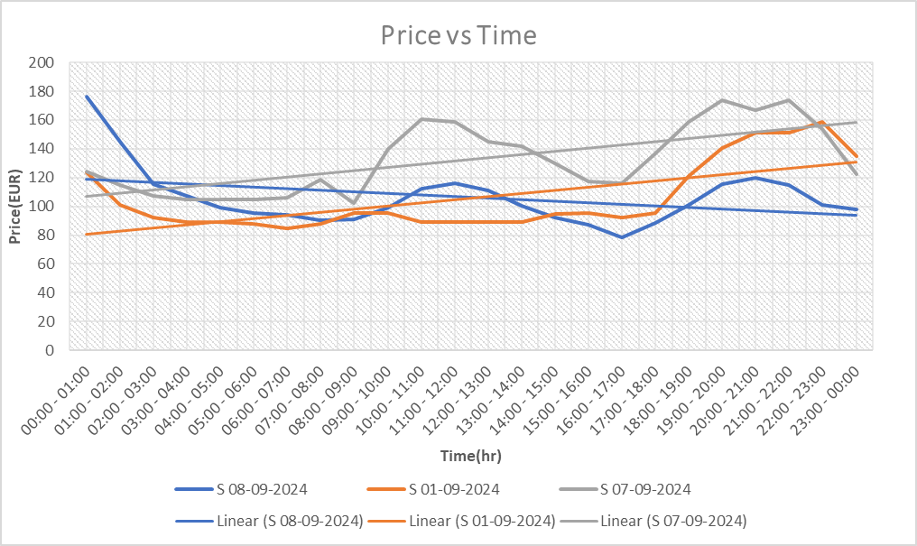

* **Renewable Energy Impact:** Fluctuations in wind and solar generation had a noticeable impact on price volatility. On days with higher renewable energy generation (particularly during sunny or windy conditions), prices were generally lower, especially during the midday period when renewable sources were generating at their maximum potential.

Source (<https://www.energydashboard.co.uk/api-info> , <https://grid.iamkate.com/> )

**Key Volatility Patterns Identified**

1. **Peak Hour Volatility:** As expected, peak hours (morning and evening) exhibited the highest volatility, with price swings of up to 20% between low and high points within a few hours.
2. **Renewable Generation Impact:** Days with high wind and solar generation tended to have smoother price curves, with less volatility during daylight hours. Conversely, on days with low renewable generation, price volatility was significantly higher as the market relied more heavily on traditional generation sources.
3. **Weekend Stability:** The weekends were characterized by lower overall price volatility, particularly in the evening peak, as demand from businesses and industries dropped.

**Proposed Trading Strategy**

Based on the observed patterns, a simple intraday trading strategy can be proposed to capitalize on the identified price movements. The strategy is built around taking advantage of the predictable price fluctuations during peak and low demand periods.

1. **Morning Peak Buying**

* Entry Point: Buy electricity during the early morning hours (before 7:00 AM) when prices are at their lowest due to reduced demand.
* Exit Point: Sell during the morning peak (7:00 AM to 11:00 AM) when prices typically rise due to increased demand from households and businesses.
* Expected Profit: The analysis suggests a potential profit margin of 20% to 25% during this period.

1. **Midday Dip Strategy**

* Entry Point: Sell electricity contracts before the midday dip (around 11:00 AM) when prices stabilize or decline as demand softens.
* Exit Point: Buy back contracts during the midday dip to benefit from price decreases, particularly on days with high renewable generation.
* Expected Profit: This strategy is particularly effective on sunny or windy days, with an expected profit margin of 8% to 10%.

1. **Evening Peak Selling**

* Entry Point: Buy electricity in the afternoon hours (before 5:00 PM) when prices are lower due to moderate demand.
* Exit Point: Sell during the evening peak (7:00 PM to 10:00 PM) when prices surge due to residential demand.
* Expected Profit: This period tends to offer the highest profit potential, with margins of 10% to 13%.

1. **Weekend Hedging**

* Strategy: During weekends, traders can hedge their positions by entering into contracts for both low- and high-demand periods. Given the lower volatility, this strategy aims to minimize risk while capturing moderate price movements.

**Conclusion:**

The intraday electricity market in Great Britain exhibits clear patterns of volatility driven by demand cycles and renewable energy generation. Peak hours, both in the morning and evening, offer substantial trading opportunities due to predictable price surges. The proposed trading strategy leverages these regular fluctuations to optimize buying and selling times, potentially offering profit margins ranging from 10% to 25% depending on the time of day and market conditions. External factors such as weather patterns and industrial demand should also be considered to further refine their strategies.